|  |  |  |
| --- | --- | --- |
|  | SRM INSTITUTE OF SCIENCE AND TECHNOLOGY  SCHOOL OF COMPUTING  DEPARTMENT OF DATASCIENCE AND BUSINESS SYSTEMS  21CSC202J OPERATING SYSTEMS |  |
| **MINI PROJECT REPORT**  **FILE MANAGEMENT SYSTEM** | | |
| **Name A. JENNIE PRIYANKA, N.NARENDRAN**  **Register Number: RA 2112702010001,RA2112702010005**  **Mail ID: ja3107@srmist.edu.in,nn47902srmist.edu.in**  **Department: COMPUTATIONAL INTELLIGENCE**  **Specialization: COGNITIVE COMPUTING**  **Semester:3** | | |
| **Team Members**  A. Jennie Priyanka RA2112702010001  N. Narendran RA2112702010005 | | |

**ABSTRACT**

The project entitled **FILE MANAGEMENT SYSTEM** software systems, sometimes called file tracking software or file managers are **how a business store and organizes electronic documents or captured data from paper-based documents**

According to development requirements, a standardized management system is mainly used in basic information management files, file statistics and query management, file lending management. Development files for standardized management system that school personnel more efficient file management functions within the scope of work documents, files, archiving and management, promoting the school to improve the level of records management staff, increase their strength, and speed up the school on the pace of information technology to make the management more standardized and efficient. This paper introduces The Design and Development of a School File Management System for Standardized. Keywords-file; management system; standardization In order to better manage the school's archives, in order to better ensure the integrity of the archives, to standardize the school to the records management standard, my company decided to develop school file standardized management system. Therefore, the file management system from unit files management practice, in accordance with national standards and relevant industry standards at the same time, in the "people-oriented" principle, suitable for the development of the middle and primary school of the characteristics of the actual file management software.

Table of Contents

Abstract

Chapter 1 : Introduction

Chapter 2: Review of Existing methods and their Limitations

Chapter 3 : Project Paradigam

Chapter 4: Modules

Chapter 5: Implementation

Chapter 5: Output Screenshots

Conclusion

References

Appendix A – Source Code

Appendix B – GitHub Profile and Link for the Project

**CHAPTER -1**

**INTRODUCTION:**

**1. PROBLEM STATEMENT**: Handling File Management System

There are courses that do not provide an option for revaluation, but at the time of valuation, it is done in two stages i.e. by two staff members. But there is course which provides the facility for revaluation, but initially the paper is valued once. The software

should be designed and developed in such a way that it accommodates all needs in dynamic fashion. It should be a general purpose one.

The first problem is that there are loads of hard copied documents are being generated. Keeping the information in the form of hard copied documents lead to many problems .

All the process done manually at the centers and all the records are maintained on the papers. So the maintenance of the record is very difficult in the departments as well as it is very difficult for the staff to check the record. The existing system is monotonous, time consuming, less flexible and provides a very hectic working schedule. The chance of loss of record is very high and also record searching is very difficult. Maintenance of the system is also very difficult and take a lot of time. Result processing is slow due to paper work and requirement of staff.

**1.1 BACKGROUND :**

File management is one of the basic and important features of operating system. Operating system is used to manage files of computer system. All the files with different extensions are managed by operating system.

A file is collection of specific information stored in the memory of computer system. File management is defined as the process of manipulating files in computer system, it management includes the process of creating, modifying and deleting the files.

Our files have several common characteristics built in. Each file is made up of data, but also metadata is embedded into the file to help the operating system (OS) manage how the file works and how it is stored. Metadata records file information such as the author, file creation date, modified date, and file size.

File management is a process of maintaining any kind of records in a proper manner like your work document or your money records this is the process to divide things in different stages and in writing from so that in future when needed it will be easy to get that particular record.

In the 20th century, vertical filing cabinets were introduced to store a different kind of files. Then the computer was used to store a different kind of file in the system with the help of the LAN/wan network. Then portable flash drive was introduced to store files and to transfer data from one system to another. Then cloud storage was introduced this cloud storage made easy to store files from anywhere and from any computer this prevent the user from losing the data or from any data threat with their high-security methods.

Computer users engage with digital files and folders on a daily basis. These interactions include creating, downloading, naming, moving, saving, copying, reviewing, navigating, looking for, sharing, and deleting them. File management is this process (FM). File administration is the process of naming, classifying, handling, and systematically storing documents. to make data retrieval easier in the future. A form of software called a file management system is used to handle data files on a computer system. It has limited features and is made to manage single or many files, such as unique office records and papers.

Some of the tasks carried out by the operating system of any computer system's file management include the following:

1. Adding new files to the computer system and putting them in the right places helps.

2. It facilitates fast and simple finding of these files within the computer system.

3. Keeping the files organized in distinct directories is helpful. These folders aid users in speedy file searches or file organisation based on use or kind.

4. It enables the user to edit file data or change a file's name in directories, among other things.

File management enables users to systematically organise their priceless papers for better and more effective utilization.

**CHAPTER -2**

**2 EXISTING SYSTEM**

In the existing system giving rights to the groups and files both were not given. A single history was saved for the project. The file manipulating method was not done in a centralised manner. In the existing system when the file is being modified the change in version number is done by the particular user. Searching process is mainly done on the file name itself.

**2.1 PROPOSED SYSTEM**

In the proposed system rights to the groups and files were separately given. The members in a particular project group cannot work in another project at the same time. Along with this right file accessing privileges are also set for each member in the project. Two different histories are maintained along the project. The file manipulating process is controlled by a centralised controlling system. The version numbering process is done automatically. When a particular user access a file and update it and when uploading the to the server its version number automatically increases and the latest version of the file will be stored in server. The searching process is done in two ways. One is filename and the other is by metadata search.

**CHAPTER - 3**

# 3. PROJECT PARADIGM

The file is actually the collection of associated information. This file-system prearranged into directory for efficient usage. Every directory has a number of files and other directories. The directory is defined as a bit which distinguish the entries that explained file and subdirectories in the recent directory. By theoretically we may change the file into a directory by changing its bit. A file system is considered as an element of an operating system that manage the storage space and operation of files on media like disks.

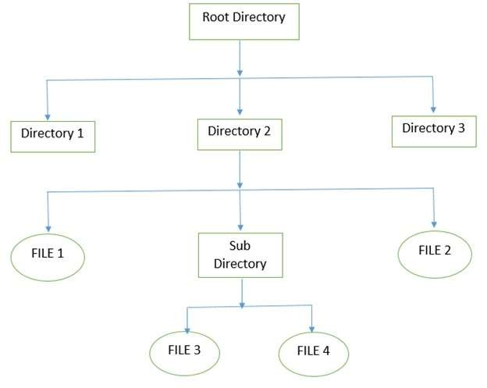

The above figure shows the general hierarchy of the storage in an operating system. In this figure the root directory is present at the highest level in the hierarchical structure. It includes all the subdirectories in which the files are stored. Subdirectory is a directory present inside another directory in the file storage system. The directory base storage system ensures better organization of files in the memory of the computer system.

**CHAPTER-4**

MODULE DESCRIPTION

No other remaining side work apart from the displayed work above is used in this project. All the functionalities and code of each function is explained above. In this project we use Ubuntu subsystem terminal with C language and bash scripting. So no others platform, API or plug in’s used in this project

**CHAPTER-5**

# FUNCTIONALITIES:

The following are some of the functionalities or tasks performed by file management system:

* 1. List all Files and Directories.
  2. Create New Files.
  3. Delete Existing Files.
  4. Rename an Existing Files.
  5. Edit Files Content.
  6. Search for Files.
  7. Details of Particular File.
  8. View Content of File.

OUTPUT:

## Main Menu:

Main menu of Project that display all the available option to the users. The users need to choose one out of 14 and the particular command will be executed according to the user input.

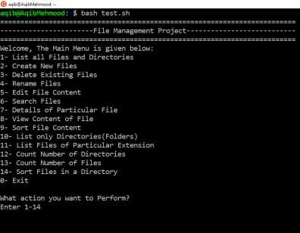

## Choice 01 Output:

If user enter 1 then the List of all Files and Directories will be displayed.

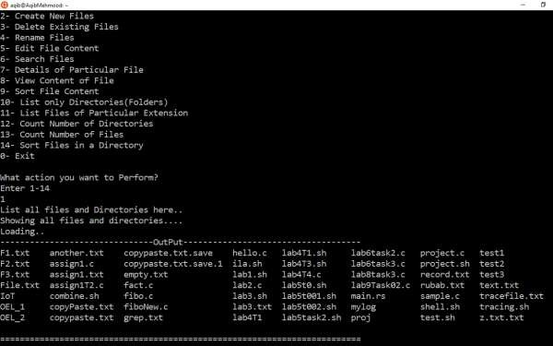

## Choice 02 Output:

If user wants to create new file then he needs to enter 2.

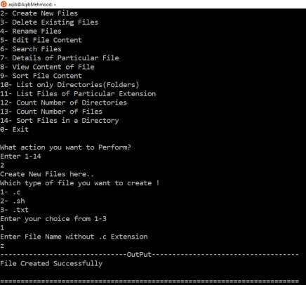

## Choice 03 Output:

If user wants to delete existing file then he needs to enter 3.

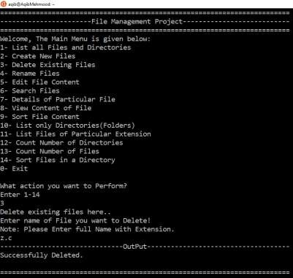

## Choice 04 Output:

If user wants to rename an existing file then he needs to enter 4.

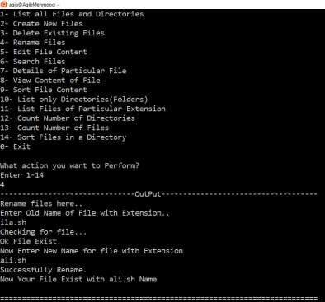

## Choice 05 Output:

If user wants to edit file content then he needs to enter 5.

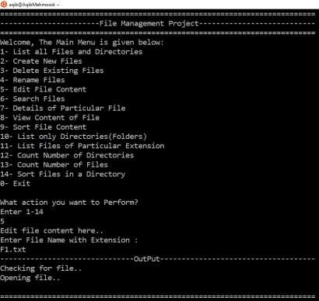

## Choice 06 Output:

If user wants to search for a file then he needs to enter 6.

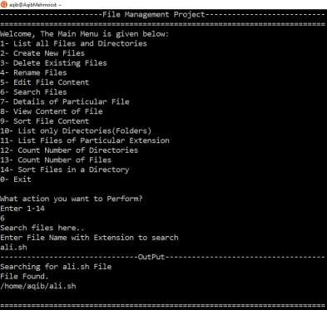

## Choice 07 Output:

If user wants to see the details of file then he needs to enter 7.

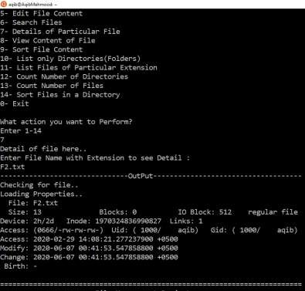

## Choice 08 Output:

If user wants to view content of file then he needs to enter 8.

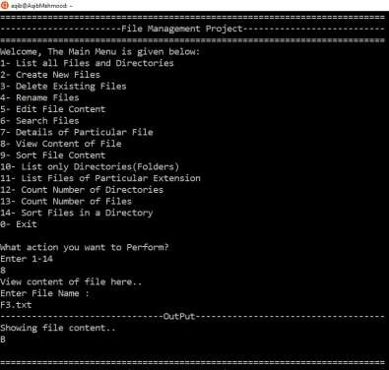

## Choice 09 Output:

If user wants to sort the file content then he needs to enter 9.

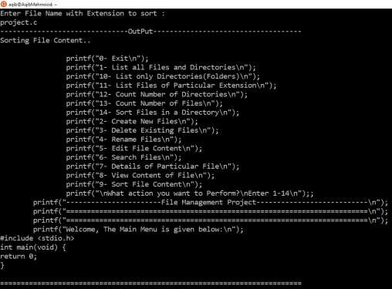

## Choice 10 Output:

If user wants to list all directories then he needs to enter 10.

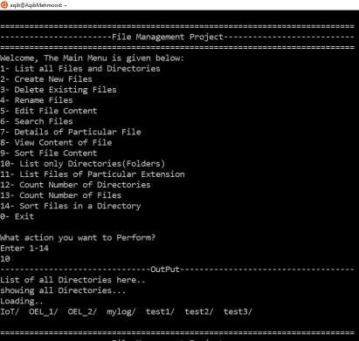

## Choice 11 Output:

If user wants to list all files with the same extension then he needs to enter 11.

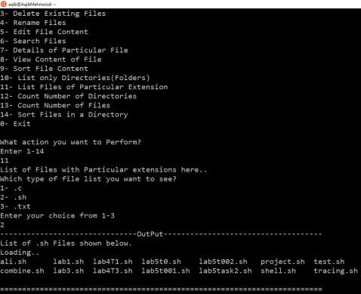

## Choice 12 Output:

If user wants to number of directories then he needs to enter 12.

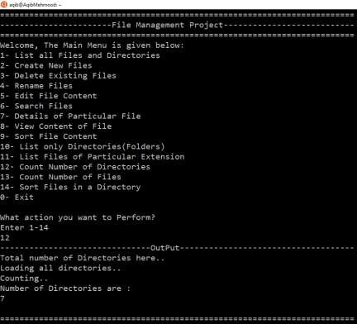

## Choice 13 Output:

If user wants to count number of files then he needs to enter 13.

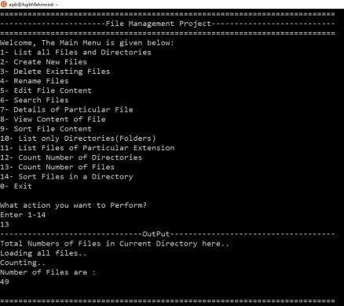

## Choice 14 Output:

If user wants to sort all files in a directories then he needs to enter 14.

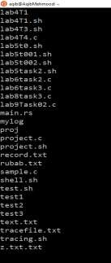

## Exit option:

If user wants to exit from Management system then he needs to enter 0.

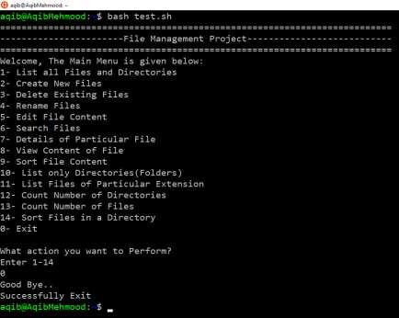

# FUTURE WORK:

This is the most basic version of file management system. So in future we can improve the current version’s functionalities and can add more new functionalities to the system. In the current version of files management system there are 13 different option for a user to manage files and directories. In future we can add more choices for users by understanding the advanced concept about file management in Linux operating system. So this will definitely help users to manage files in a more easy and comfortable manners.

# CONCLUSION:

The project contains some basic functionalities regarding file management like creating new files, delete existing files, rename files, edit files, read or write files and so on. All the functionalities are working on the basis of user’s input from keyboard. There are different basic functions that users can perform on files. These functions are written in C language and bash scripting. All these functionalities are discussed above in the form of code as well as in simple natural language. So everyone having the basic knowledge of computer can use this file management system to perform different functions on files.

# REFERENCES:

* Main Idea from includehelp.com Submitted by Amit Shukla, on August 14, 2017 < [https://www.includehelp.com/operating-systems/file-management-in-operating-](https://www.includehelp.com/operating-systems/file-management-in-operating-system.aspx) [system.aspx](https://www.includehelp.com/operating-systems/file-management-in-operating-system.aspx) >
* How to rename a file answer by Mazhar MIK on askubuntu.com

<[https://askubuntu.com/questions/280768/how-to-rename-a-file-in-](https://askubuntu.com/questions/280768/how-to-rename-a-file-in-terminal#%3A~%3Atext%3DA%20simple%20way%20to%20rename%2Cfrom%20one%20name%20to%20another.%26text%3Dwhere%20%E2%80%9Cfile1) [terminal#:~:text=A%20simple%20way%20to%20rename,from%20one%20name%20to](https://askubuntu.com/questions/280768/how-to-rename-a-file-in-terminal#%3A~%3Atext%3DA%20simple%20way%20to%20rename%2Cfrom%20one%20name%20to%20another.%26text%3Dwhere%20%E2%80%9Cfile1)

[%20another.&text=where%20%E2%80%9Cfile1.](https://askubuntu.com/questions/280768/how-to-rename-a-file-in-terminal#%3A~%3Atext%3DA%20simple%20way%20to%20rename%2Cfrom%20one%20name%20to%20another.%26text%3Dwhere%20%E2%80%9Cfile1)>

* Use of stat command answer by <<https://linuxhint.com/linux_stat_command/>>

APPENDIX A :

SOURCE CODE

## Menu Code:

#include <stdio.h> int main(void) {

printf("=========================================================================

\n");

printf(" File Management Project

\n");

printf("=========================================================================

\n");

printf("Welcome, The Main Menu is given below:\n");

printf("1- List all Files and Directories\n"); printf("2- Create New Files\n");

printf("3- Delete Existing Files\n"); printf("4- Rename Files\n"); printf("5- Edit File Content\n"); printf("6- Search Files\n");

printf("7- Details of Particular File\n"); printf("8- View Content of File\n"); printf("9- Sort File Content\n");

printf("10- List only Directories(Folders)\n"); printf("11- List Files of Particular Extension\n"); printf("12- Count Number of Directories\n"); printf("13- Count Number of Files\n");

printf("14- Sort Files in a Directory\n"); printf("0- Exit\n");

printf("\nWhat action you want to Perform?\nEnter 1-14\n");;

return 0;

}

## Main Code:

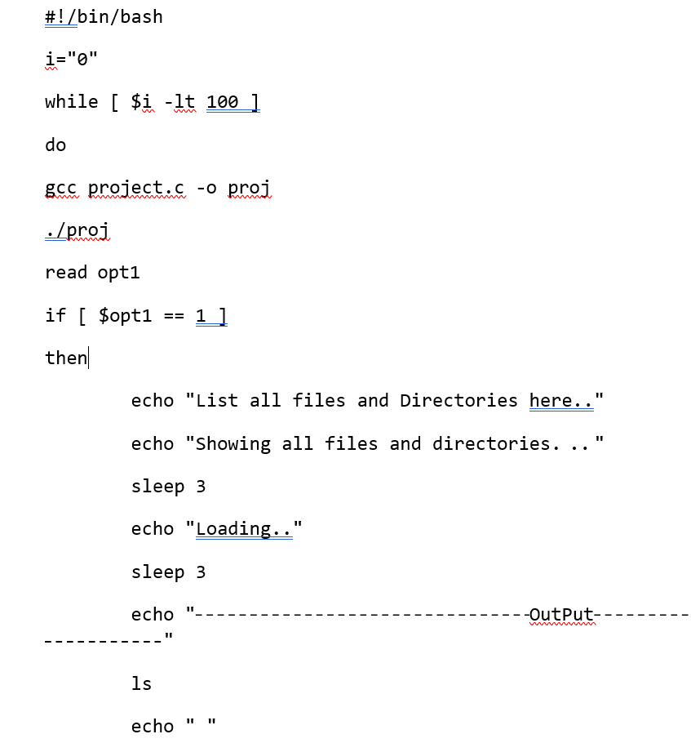

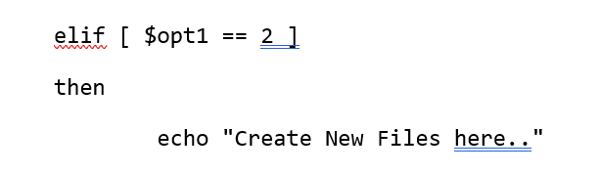

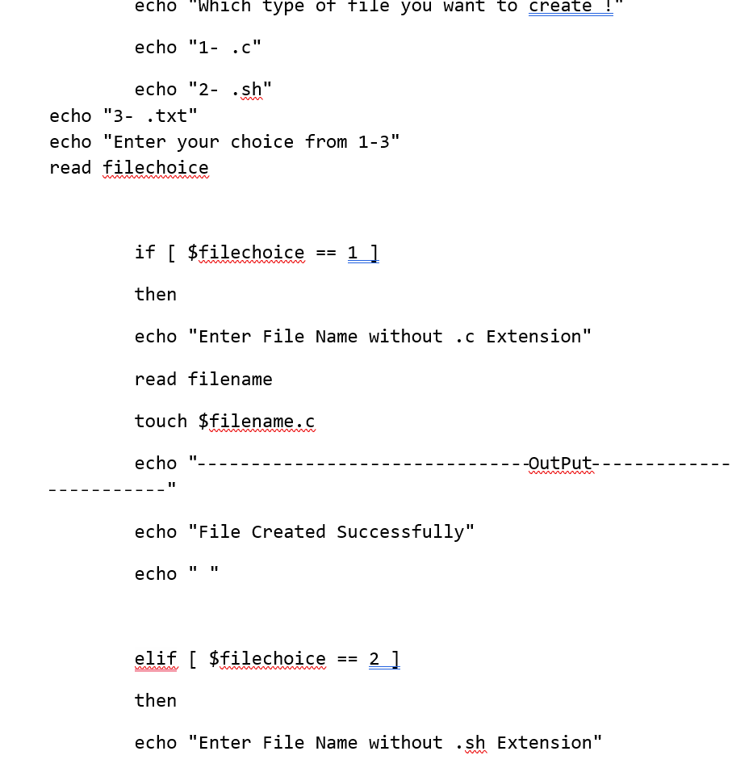

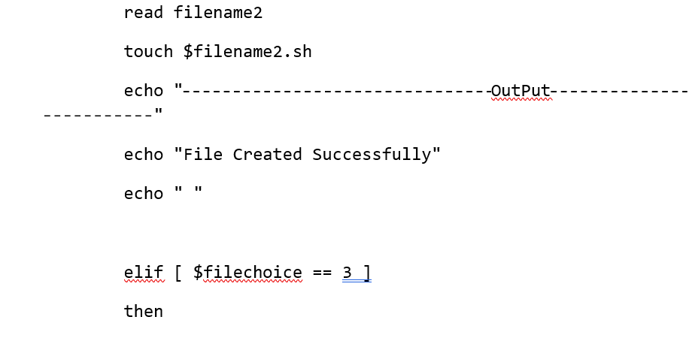

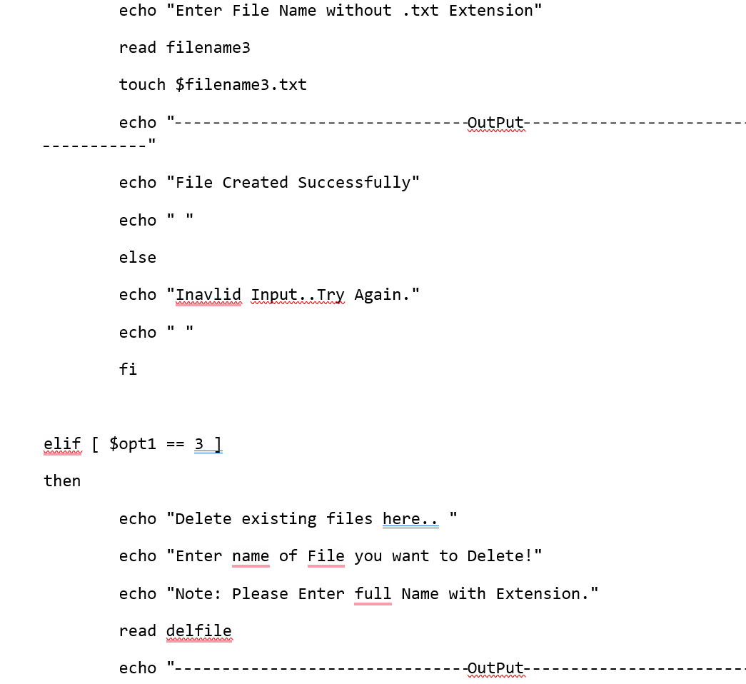

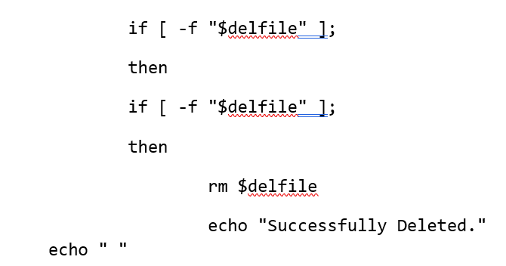

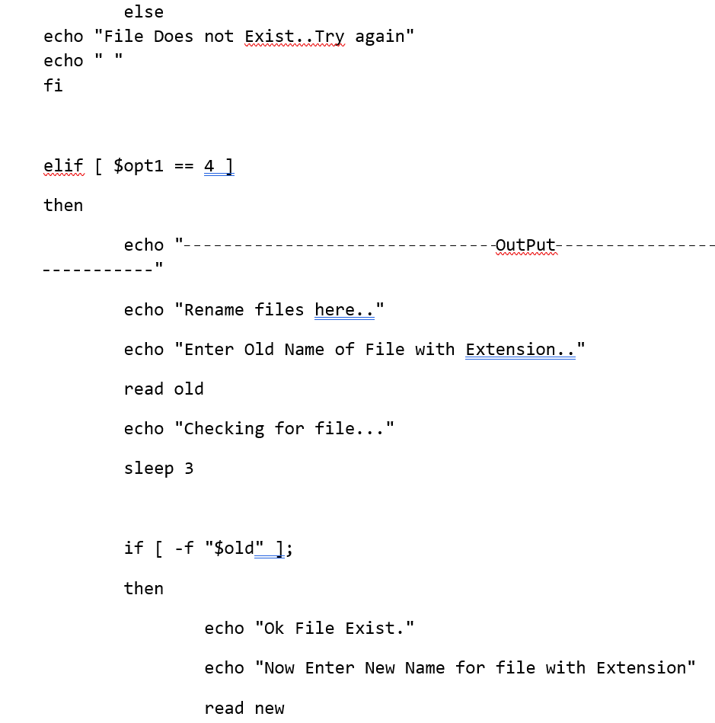

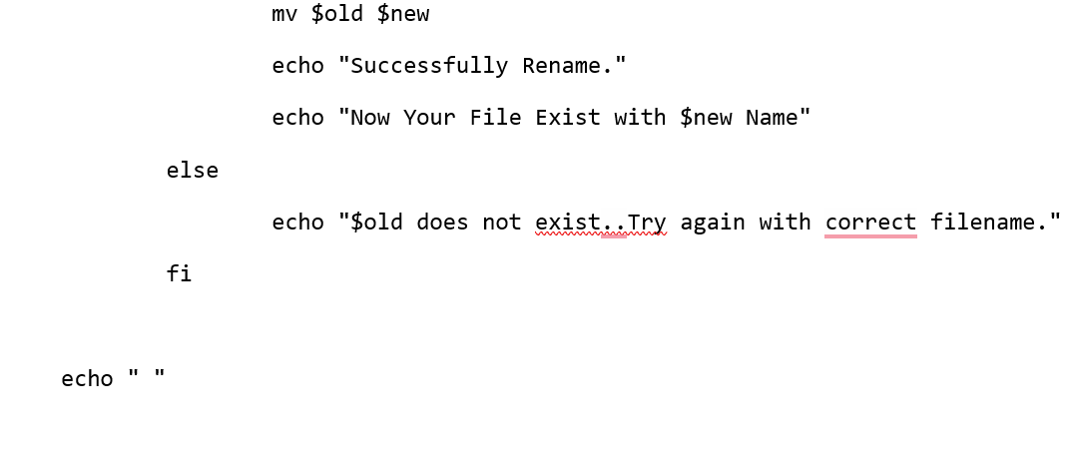

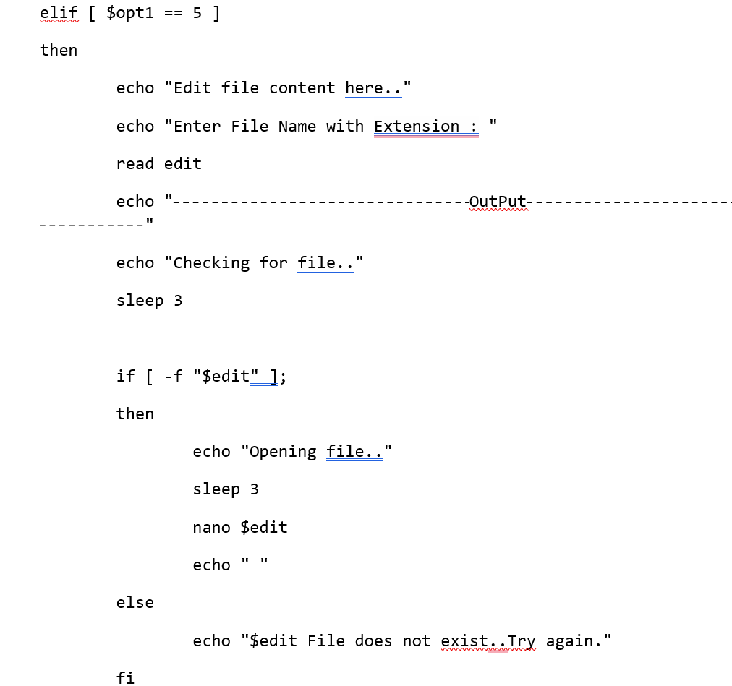

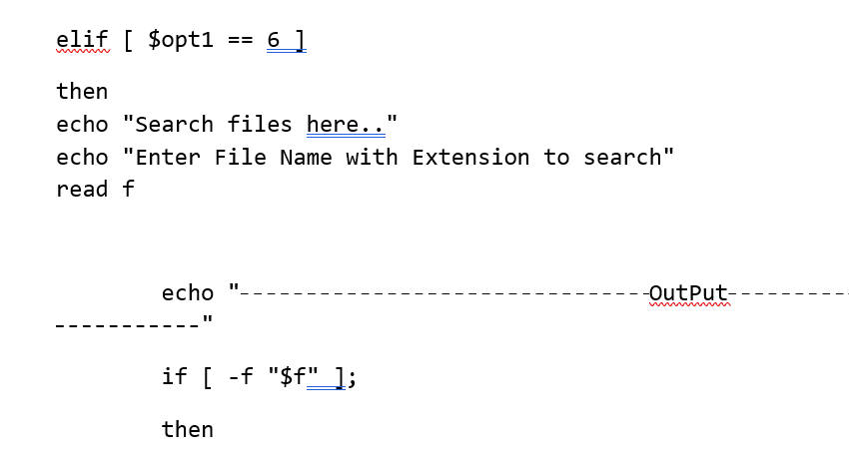

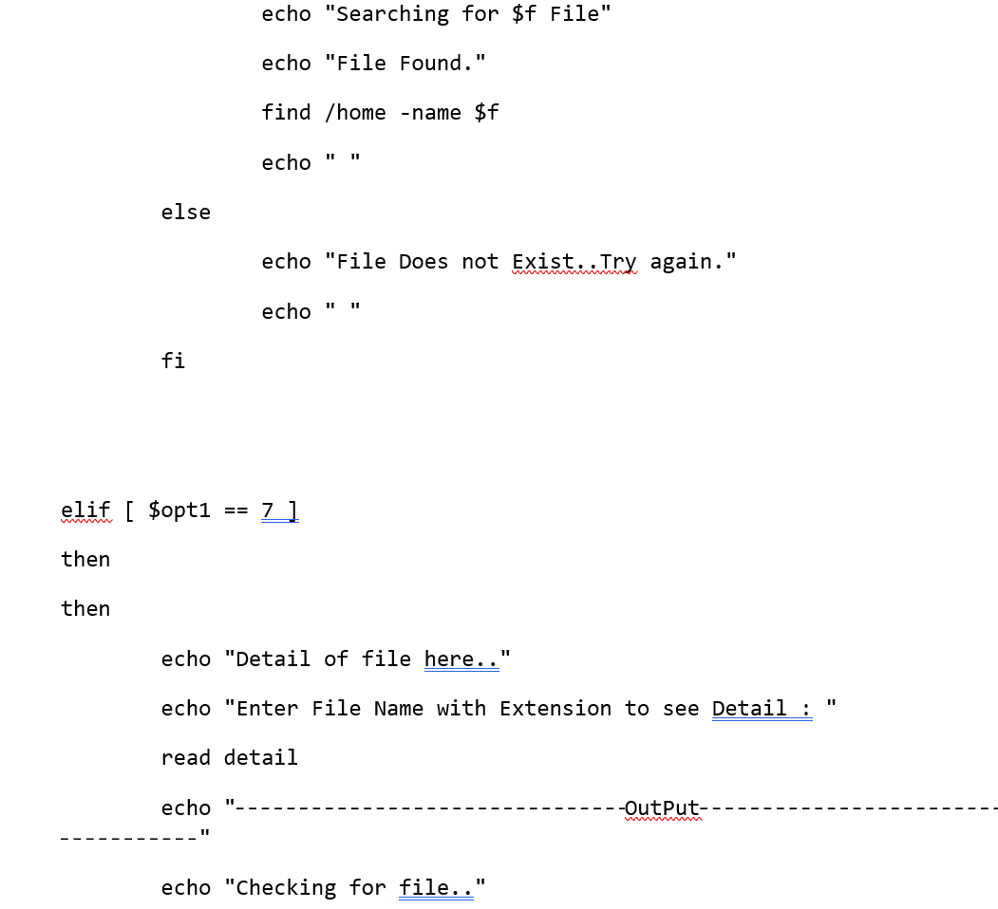

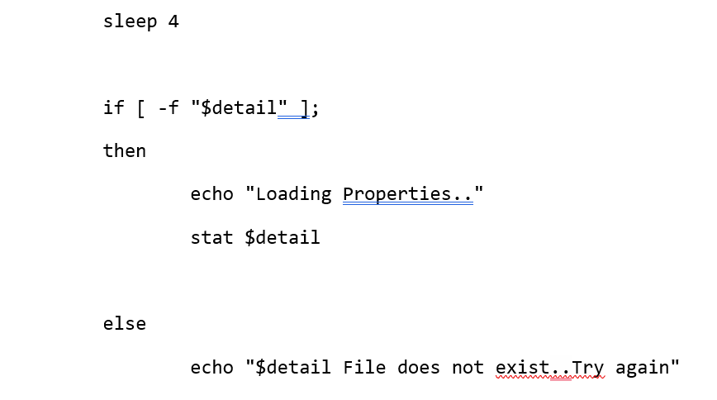

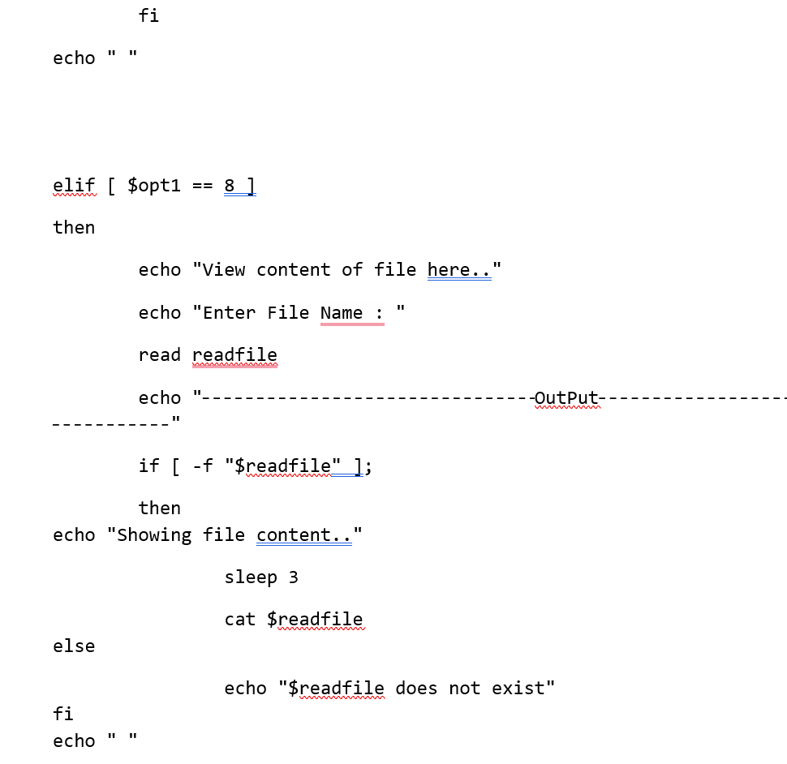

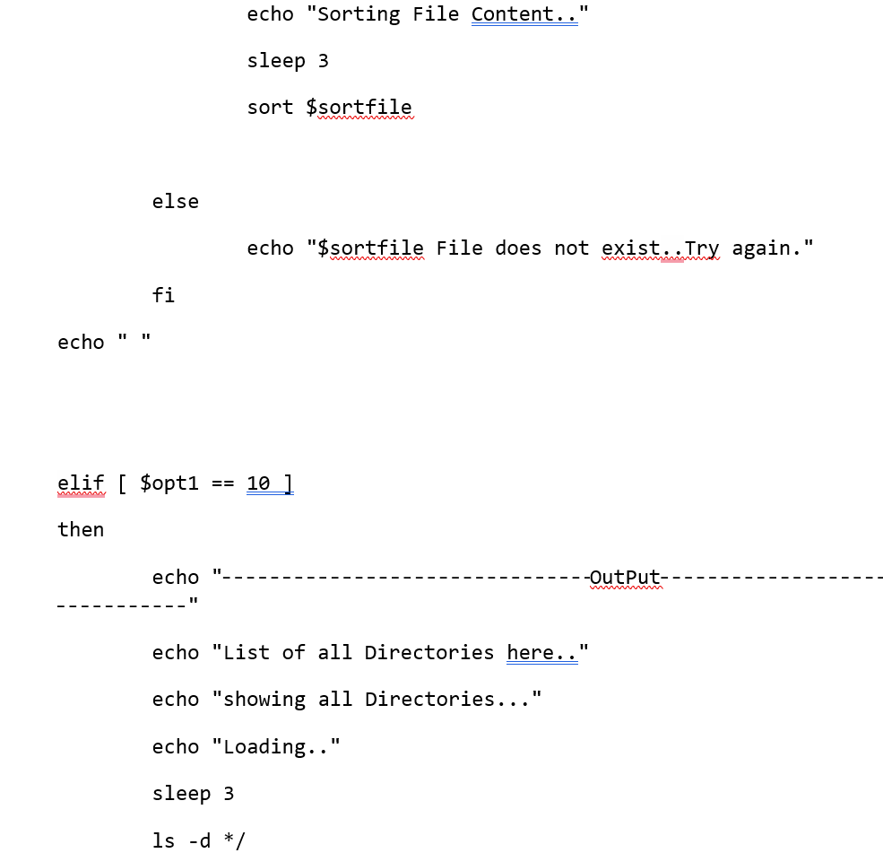

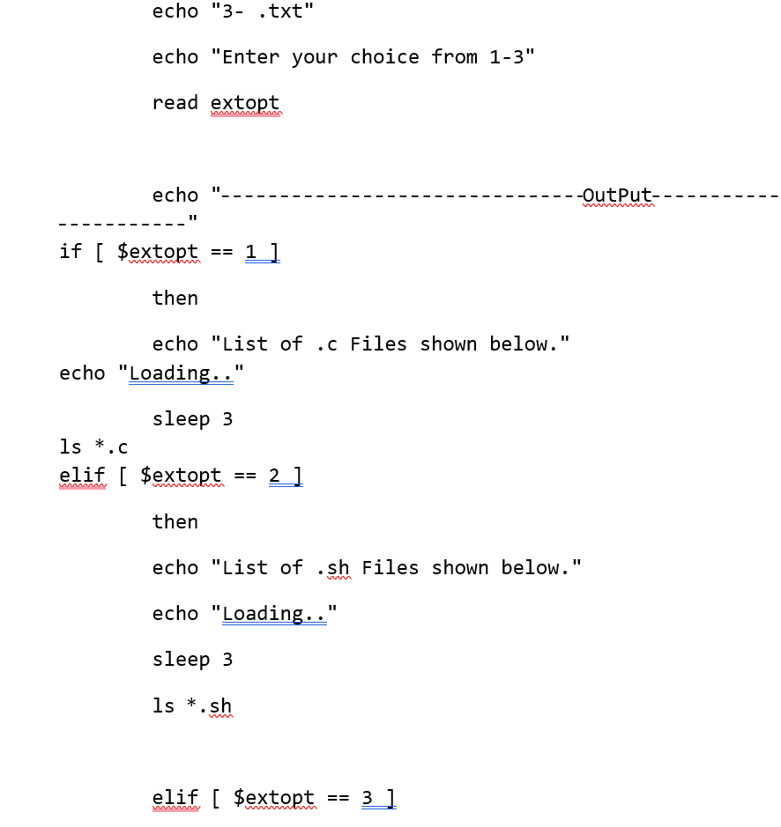

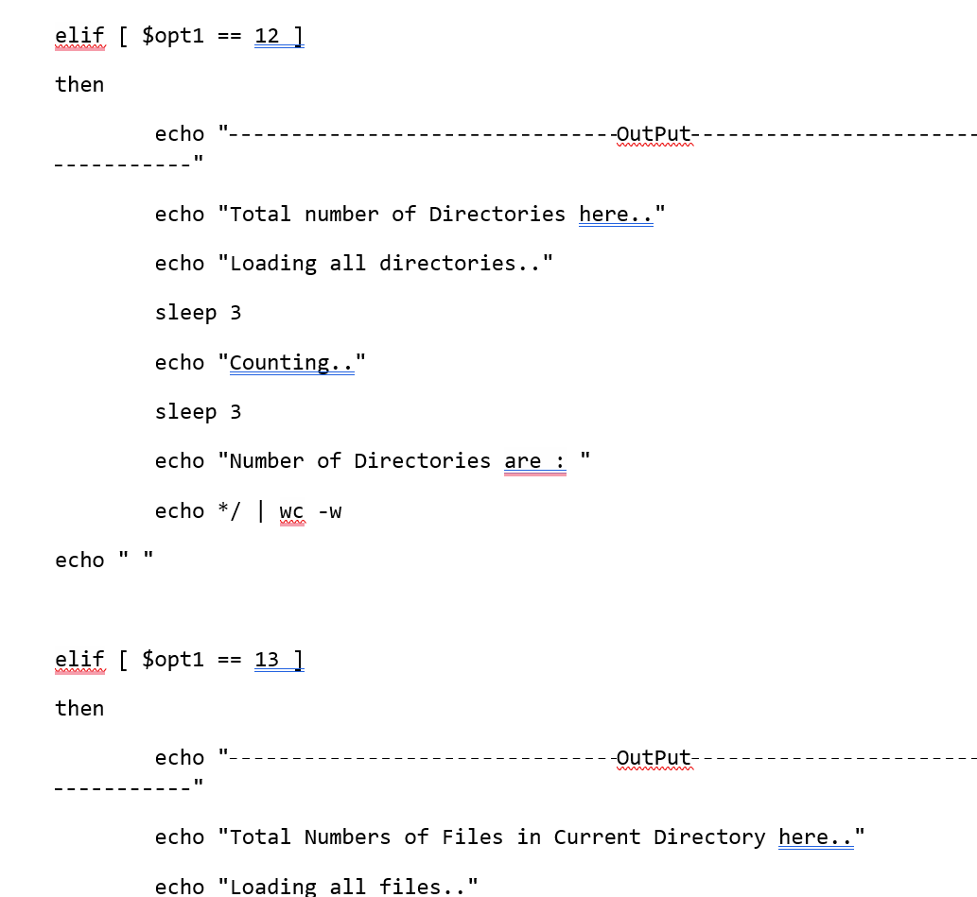

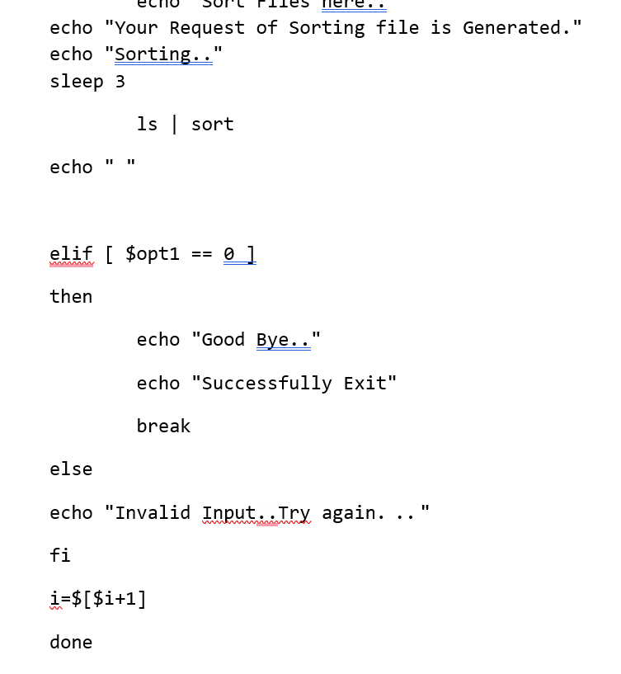

APPENDIX B :

GITHUB LINK :